**Register info**

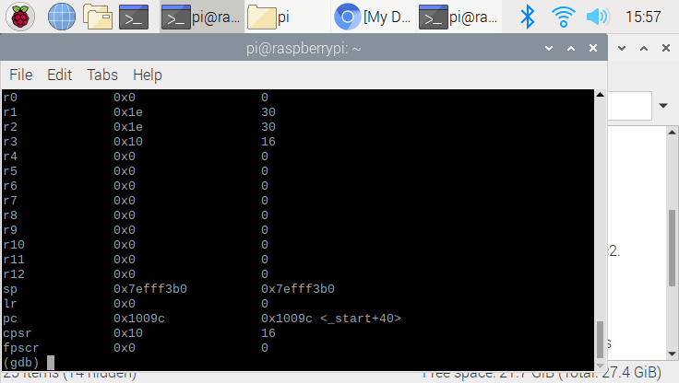

The result of the arithmetic is stored in a r1 register. The value of the result is 30, and we know that is the correct value

**Accessing the memory address using the commands**

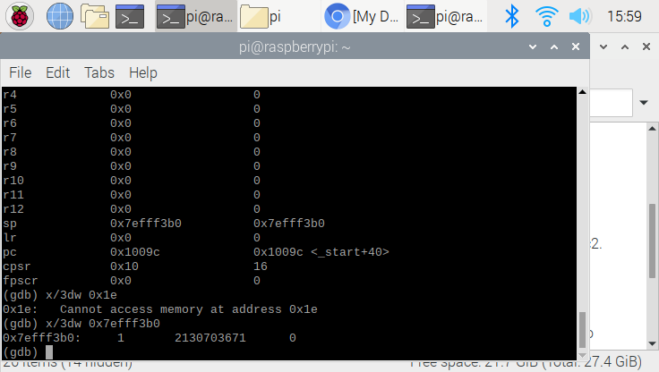

We could identify the data using the address. I have used “x/3dw 0x7efff3b0” to identify which data is stored in that address, and the code shows that address ox7eff3b0 stored 1 2130703671 (I assume it is a garbage data)

**Code**

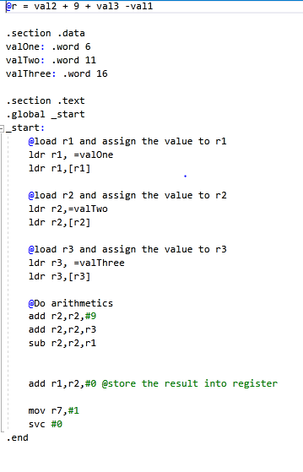

We are preforming the basic arithmetic using the register. The assign task is to calculates val2 + 9 +val3 -val1 and stored result into register. As you could see above, I have declared the global variable named as “valOne, valTwo, and valThree”. Each variable could stores a numerical number, and in this case, we store 6 11 and 16. Going into the main function, we go to main stack andload all the necessary data(in this case, load valOne, valTwo, and valThree) using ldr function. Once load is done, we now can perform the arithmetic using add and sub function. The code above will show how to use a add and sub command. Last but not least, all we need to do is to store the result value into register r1. The current result value is stored into the r2, so I have done “add r1,r2,#0.”. I do aware that I could use the “str r1,r2” to store the value , but above code also work.